**DAILY ONLINE ACTIVITIES SUMMARY**

|  |  |  |  |  |  |  |  |  |
| --- | --- | --- | --- | --- | --- | --- | --- | --- |
| **Date:** | **12/06/2020** | | | | | **Name:** | **ASHISH GRACION MENEZES** | |
| **Sem & Sec** | **4&A** | | | | | **USN:** | **4AL18CS012** | |
| **Online Test Summary** | | | | | | | | |
| **Subject** | | **AADALITHA KANNADA** | | | | | | |
| **Max. Marks** | | **25** | | **Score** | | | **15** | |
| **Certification Course Summary** | | | | | | | | |
| **Course** | **INTRODUCTION TO NEURAL NETWORKS AND DEEP LEARNING** | | | | | | | |
| **Certificate Provider** | | | **Great learning** | | **Duration** | | | **9.5 hours** |
| **Coding Challenges** | | | | | | | | |
| **Problem Statement1:Write a java program to find longest repeating sequence in a string** | | | | | | | | |
| **Status:Executed** | | | | | | | | |
| **Uploaded the report in Github** | | | | | **YES** | | | |
| **If yes Repository name** | | | | | **https://github.com/ash7745/lockdown-coding** | | | |
| **Uploaded the report in slack** | | | | | **YES** | | | |

Online Test Details1: 18KAK49 I.A. 2 was conducted on 12/06/2020. There were 25 questions (MCQ) each question carrying 1 marks.The duration of the test was 25 minutes.The portion for I.A. 2 was from all 10 chapters.

Certification Course Details: INTRODUCTION TO NEURAL NETWORKS AND DEEP LEARNING

As a part of continuation of my ongoing certification course ,Today I have listened 8 videos each of duration 22,20,21,6,27,14,21,17 minutes 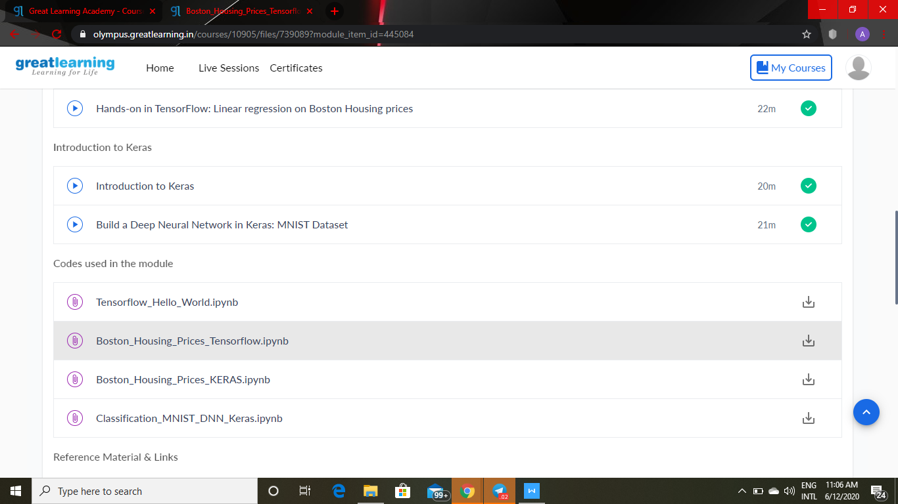

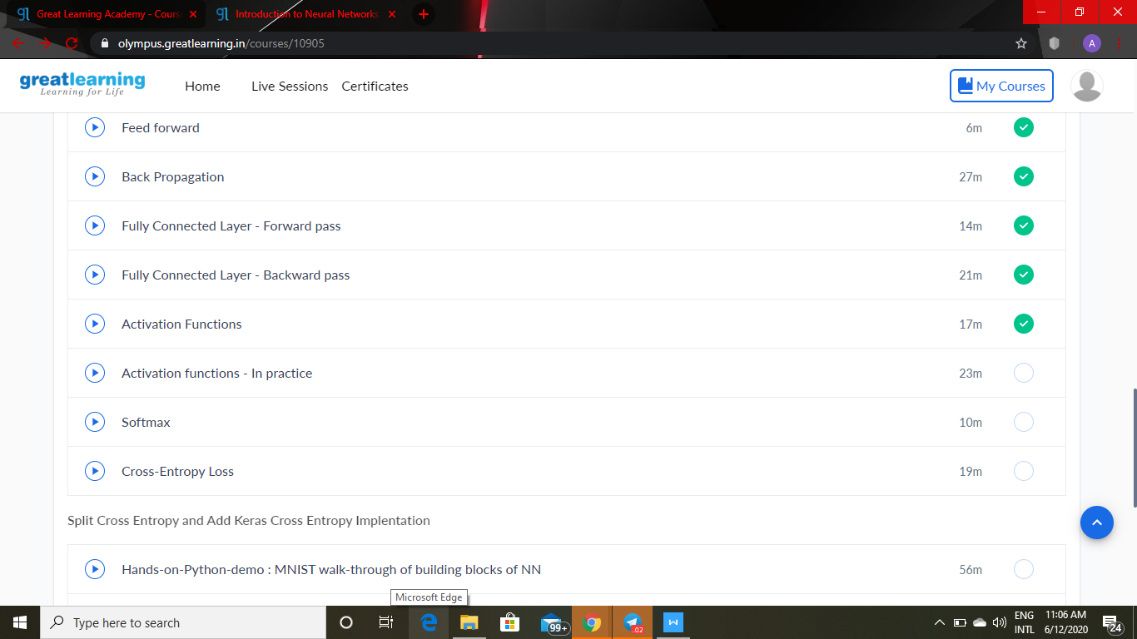

Certification details: WEBINAR ON SKILL DEVELOPMENT

On june 11/06/2020 I had attended a webinar on skill development which was conducted by Brainovision .The duration of the webinar was 3 hours.

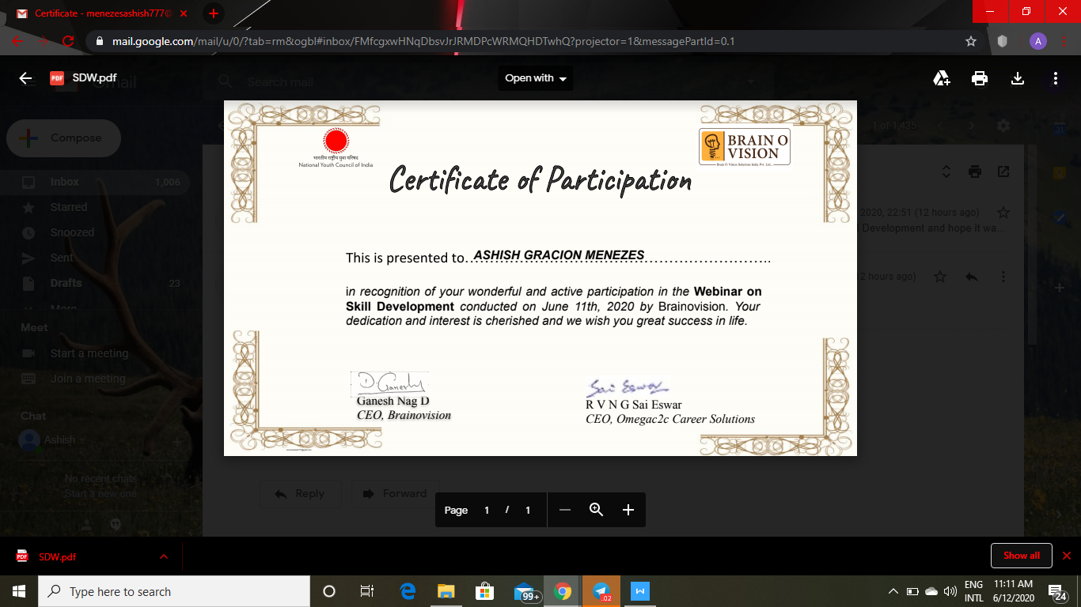

CODING DETAILS: Write a java program to find longest repeating sequence in a string